**Student: Kim Bomin**

**Student ID: 2020310050**

**Course Section Number: SWE3048_41**

**WEB PROJECT REPORT**

**[SKKU EXHIBITION]**

**Introduction**

The code used for the development of the web page specifies that it was written by myself in the fall semester of 2022.

The theme of the final project that I implemented is the skku project exhibition.

This webpage allows students of Sungkyunkwan University to display projects that they have carried out as assignments or that they have personally worked on. Anyone can visit the site to appreciate various projects and leave responses such as "like" to impressive projects. I hope to inspire motivation to learn through the website and create competition in good faith. I actually participated this semester as the sole front-end developer of the project exhibition website for ‘problem solving and algorithmic’. And based on this experience, I chose the subject of the final project. The dataset was borrowed from the project, but I did the database configuration and integration myself. I implemented the front-end part by myself, and in addition, I made some changes to the code, design, and configuration in the final assignment. The backend part was also newly implemented using Express, not Flask from the existing project, to avoid plagiarizing the implemented code.

**Used library and language**

SKKU EXHIBITION is implemented in the following libraries and languages:

1. Front-End: React, scss, html, css, javascript, axios
2. Back-End: Express, javascript, cors
3. Database: MySQL
4. Package manager: NPM

**Code History**

The GitHub link is as follows:

<https://github.com/nimod7890/Web-Programming-Lab/tree/main/final>

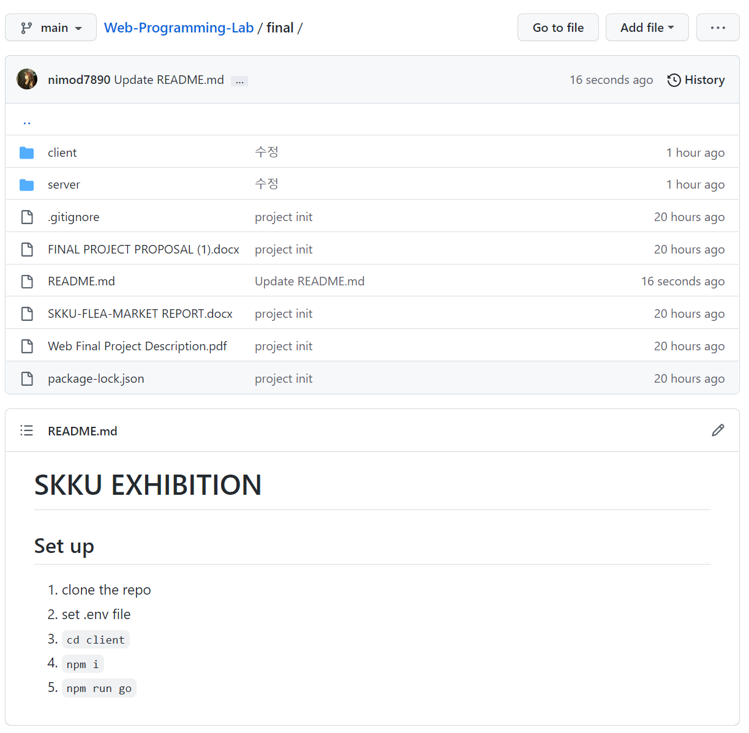

**Page**

1. **Enter page**

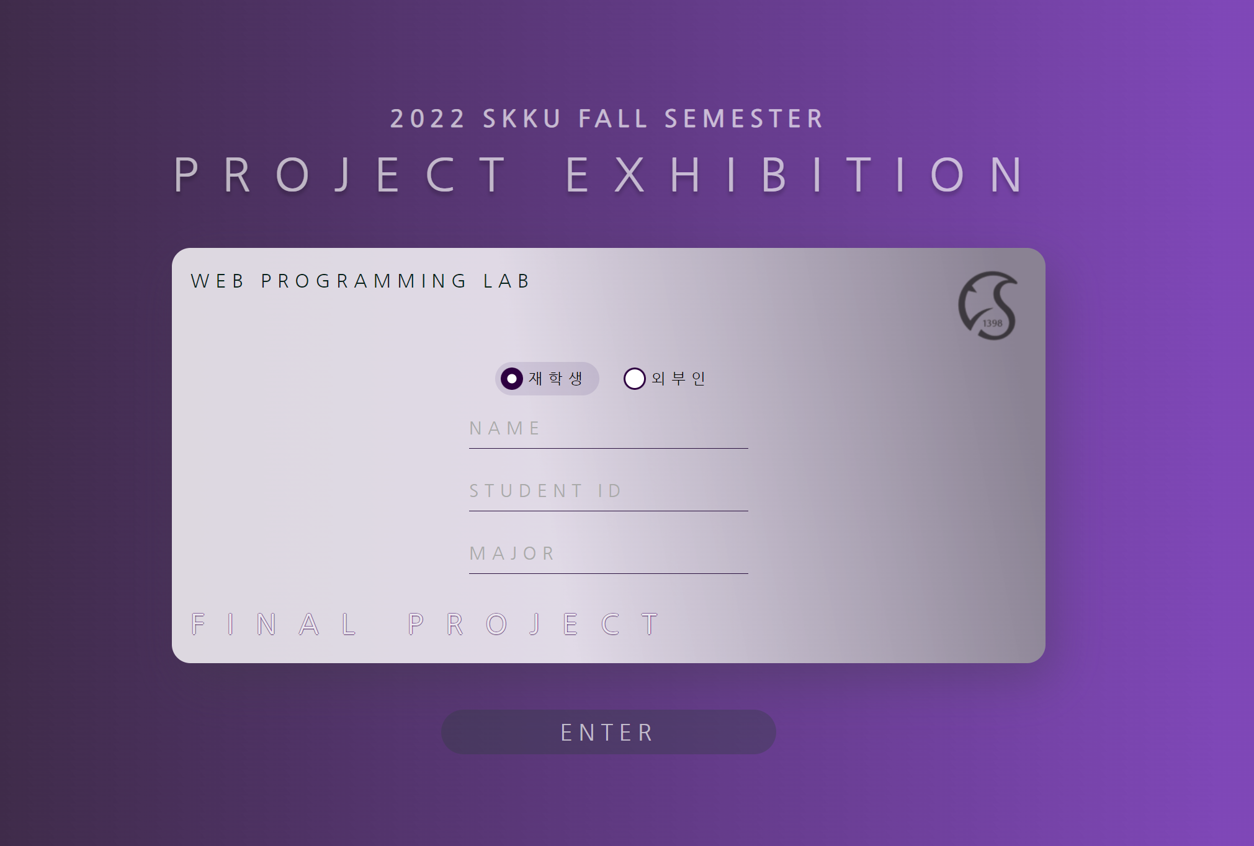

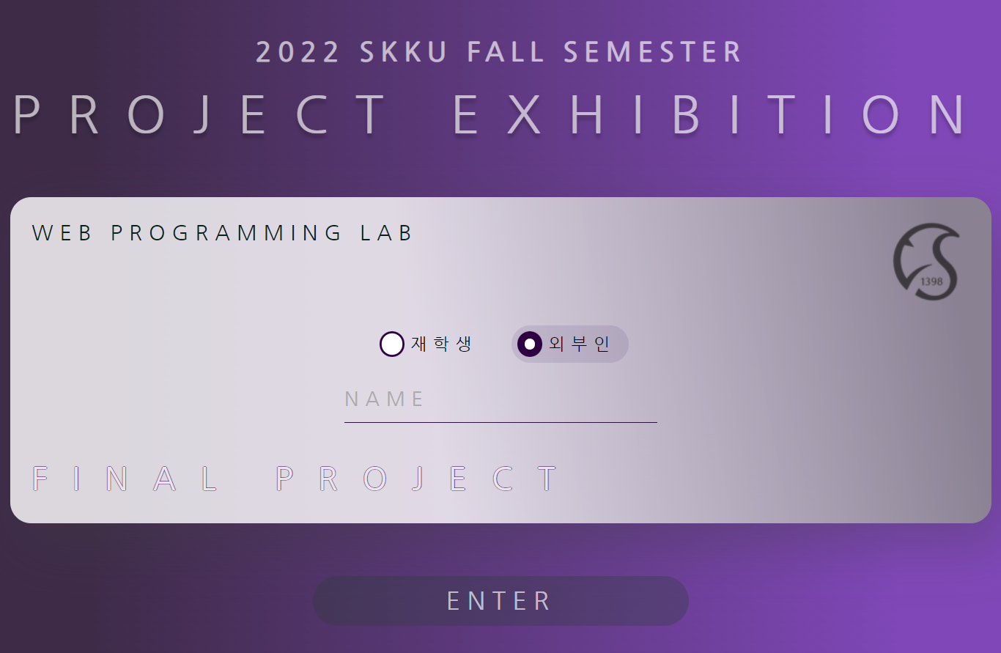

**functions**

* Collect user information by dividing into enrolled students and outsiders
  + In the case of enrolled students, collect names, academic records, and departments
  + For outsiders, collect names
* Enter at least two characters for the name and department
* For school classes, you must enter a number consisting of 10 correctly
* If you press the entry button without entering the value correctly, display the alert, empty the corresponding input space, and move the cursor to the corresponding space.

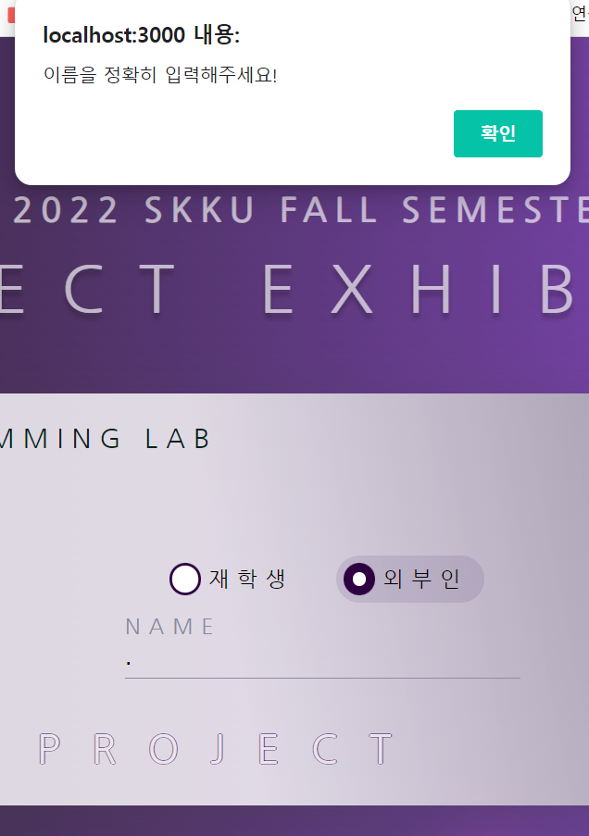 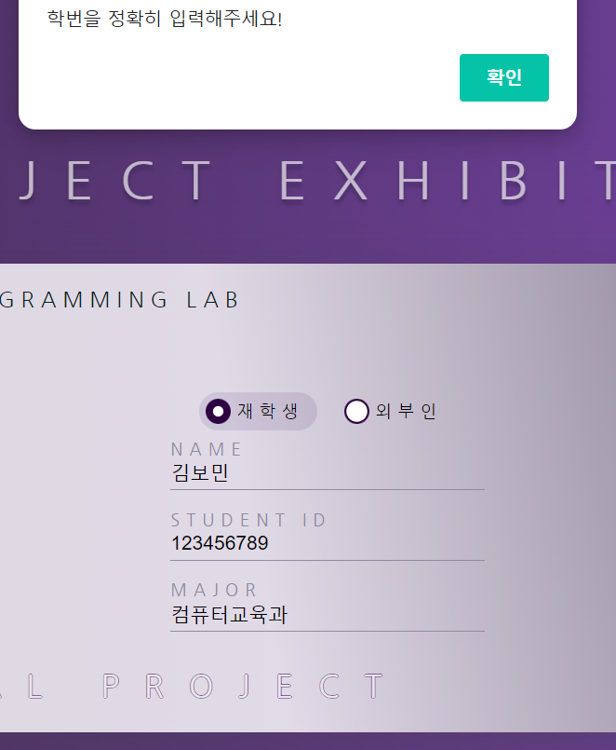

* + After logging in, the user information is stored in session storage (to fill in the visitor's name on the header).

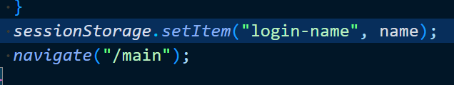

**Css points**

* When you mouse over the entry button, the atom rotates around the button.



* At the time of input, the letters NAME, STUDENT ID, MAJOR are moved up.

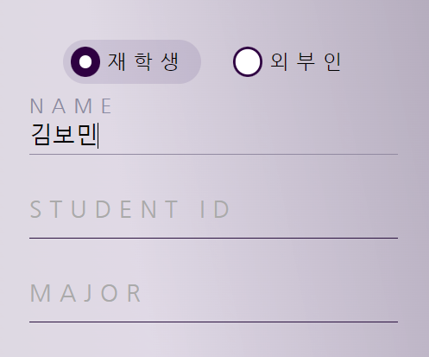

1. **Header component**



**Functions**

* Click on the left logo of the header to go to the main page
* Click the Class menu to display a list of classes that can be moved to that class.

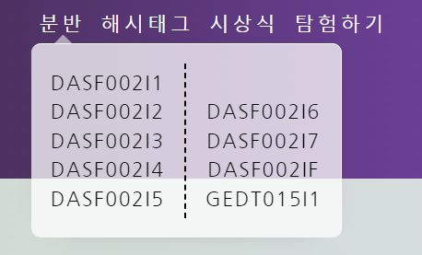

* The user name stored in the session storage is displayed in the welcome message to the right of the header.

**Css points**

* When you mouse over the menu, the letters move three-dimensionally (see 90 degree rotation, video).

1. **Footer component**



**Functions**

* Show copyright
* Add sns link: Project Github link & Instagram link
* When you click on the image, each address opens with a new tab.

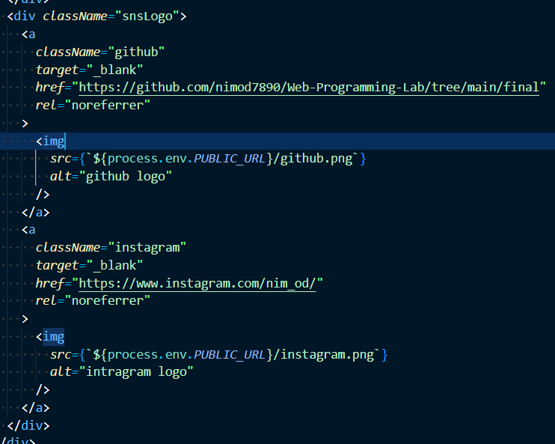

1. **Main page**

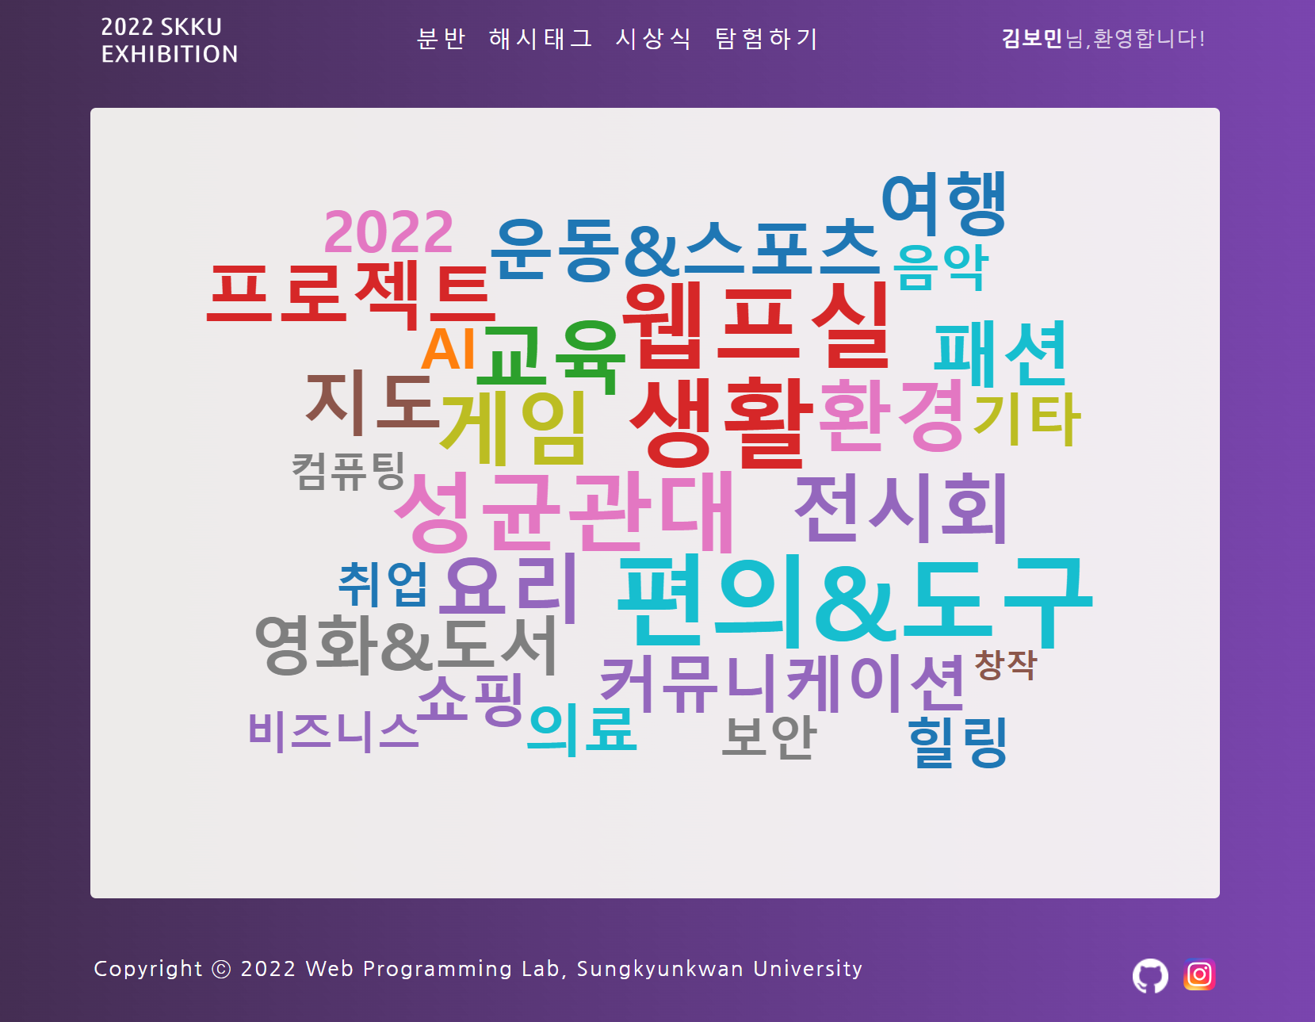 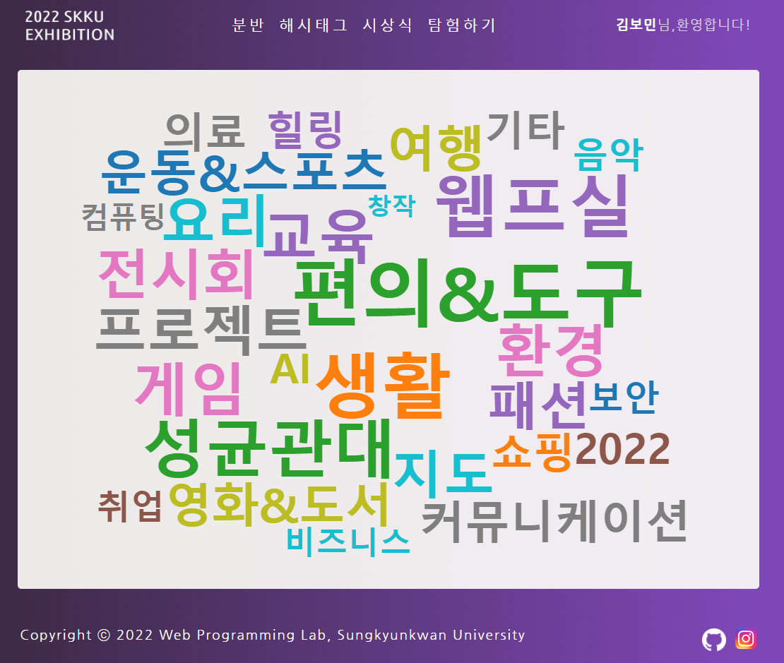

**Functions**

* Up to four hashtags per project.
* The first hashtag is used for project classification
* The rest can be specified freely for each project
* Hashtags for project classification purposes are displayed on the main page in word cloud format.
* When you select each word, go to the hashtag page where you can see the classified projects

**Css points**

* Word cloud placement and color randomly change

1. **Class Page**

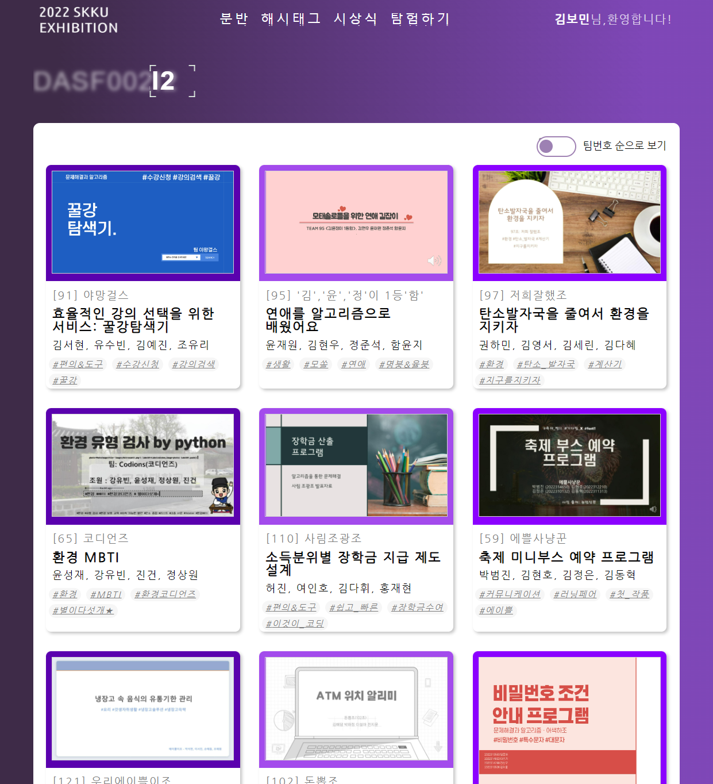 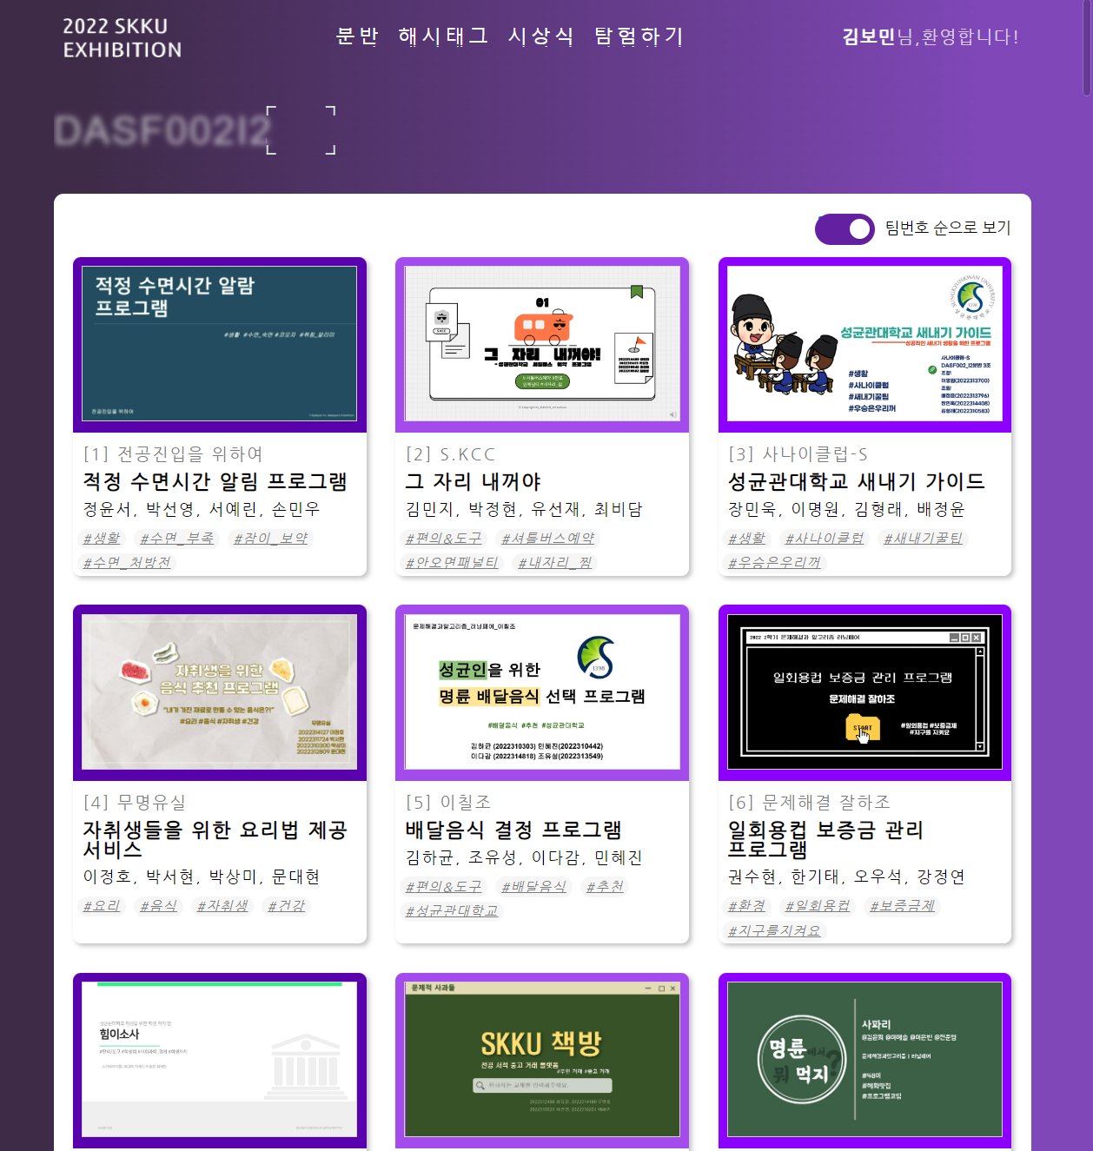

**Functions**

* When accessing a class page for the first time, randomly place projects belonging to each class by team number
* When the toggle button is pressed, projects are sorted in order of small team numbers
* If you select the toggle button again, randomly place the project in a new order

**Css points**

* Setting the image loading element to Lazy reduces the possibility of data loading delays when there are a large number of projects

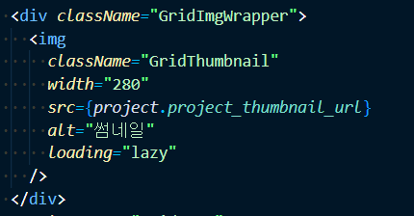

* Grids increase based on the longest project in each row considering thumbnail size, title, hashtag length, etc

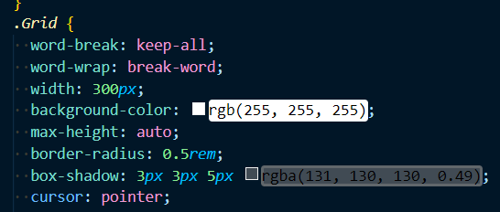

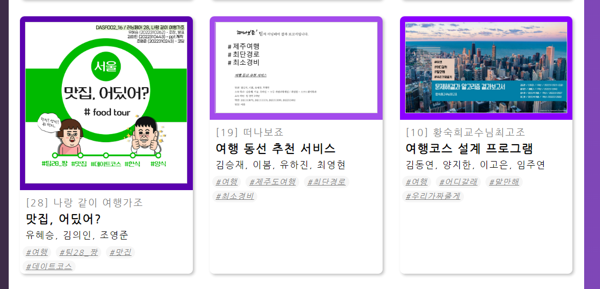

* Set thumbnail colors differently for every 3 items

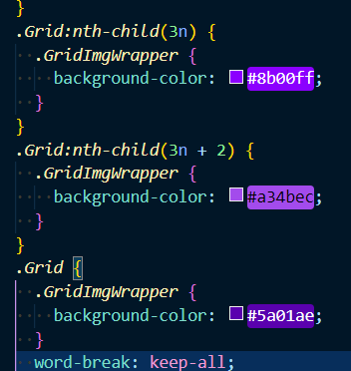

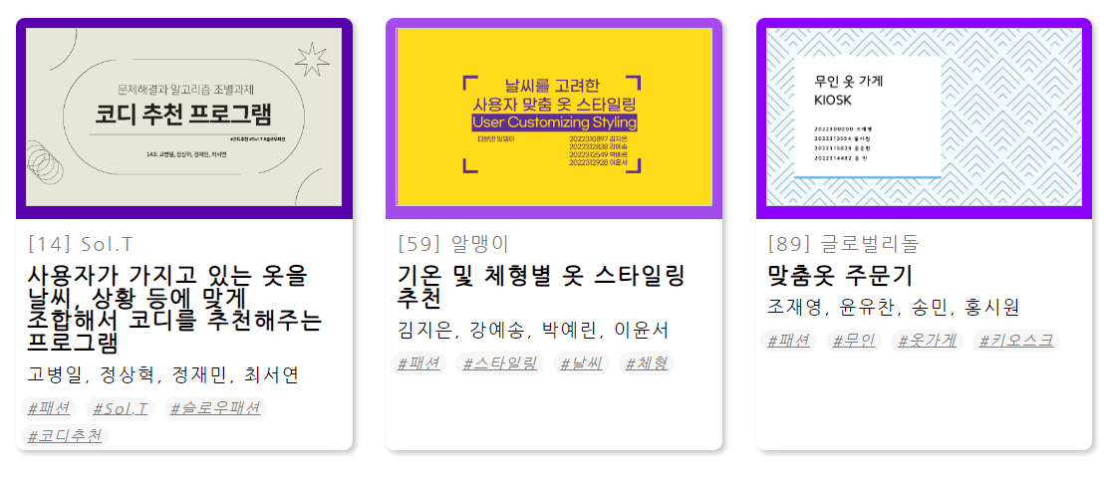

1. **Hashtag page**

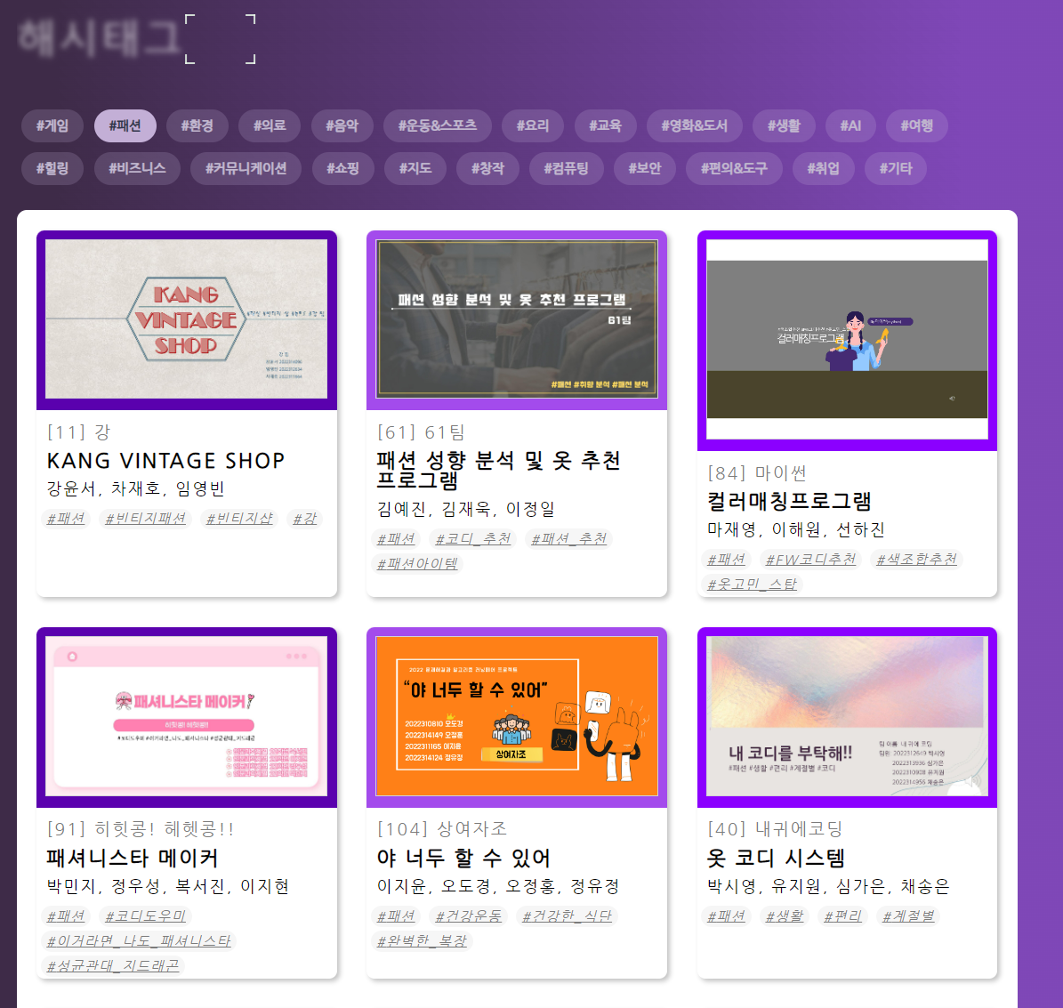

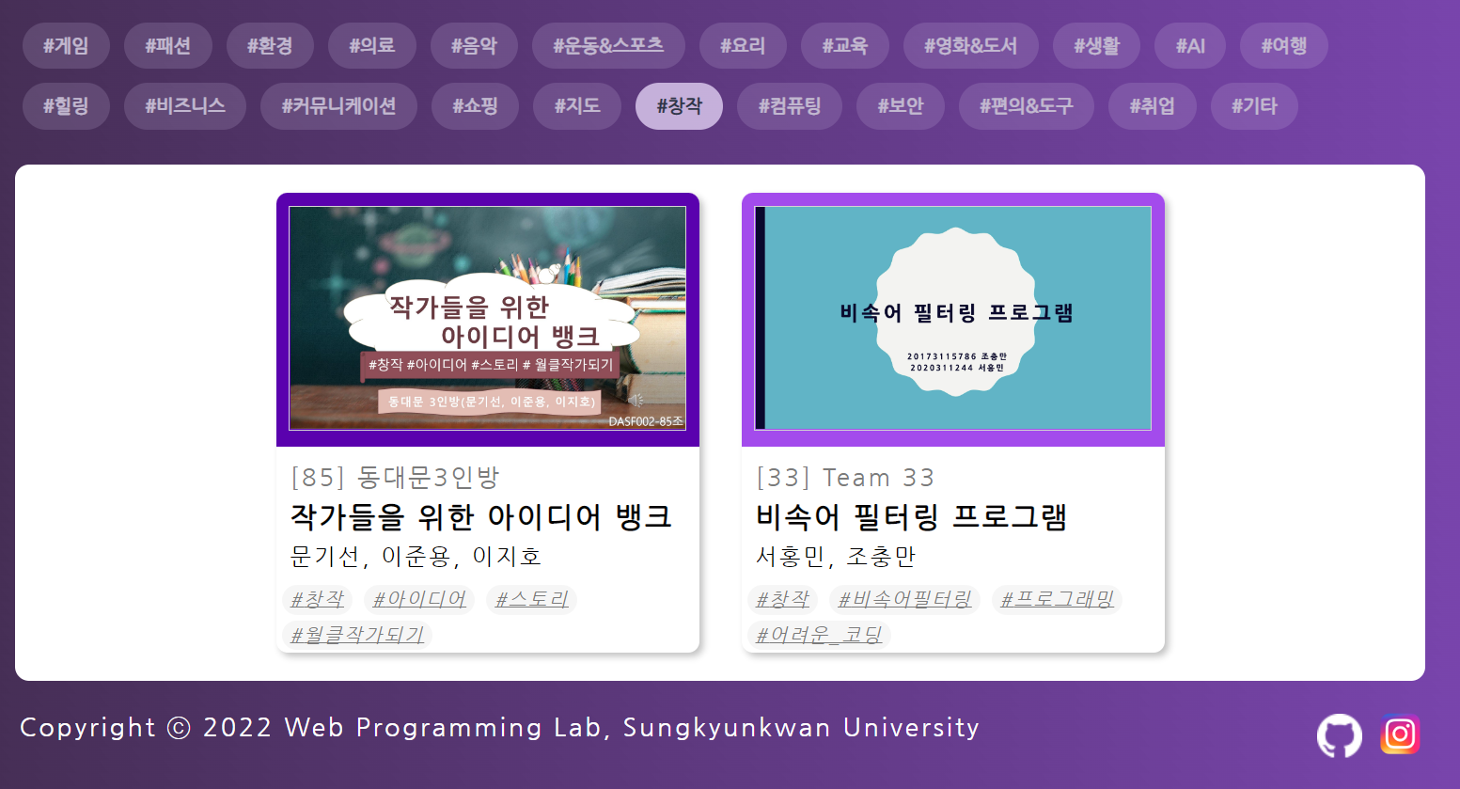

**Functions**

* When the hashtag button is pressed, it shows the projects in the corresponding classification
* Show a blank page if you don't press any buttons.

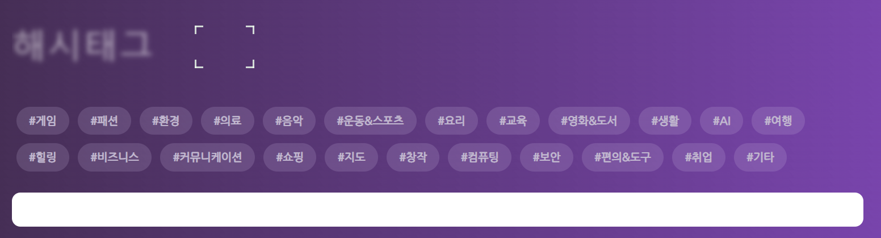

1. **Project page**

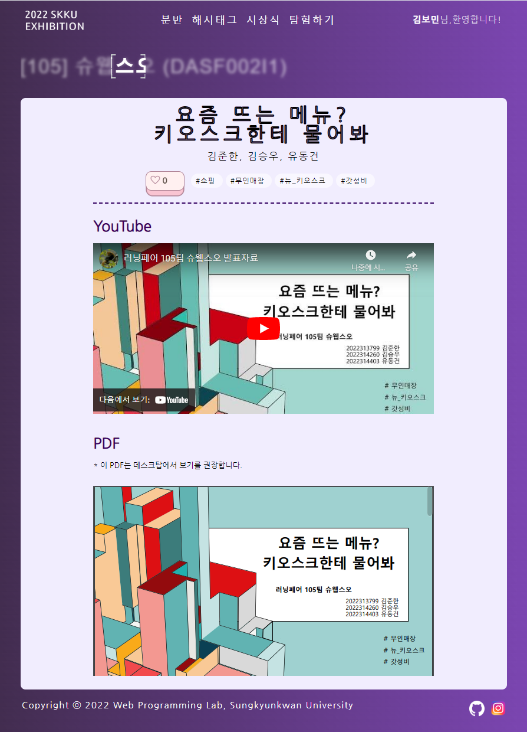 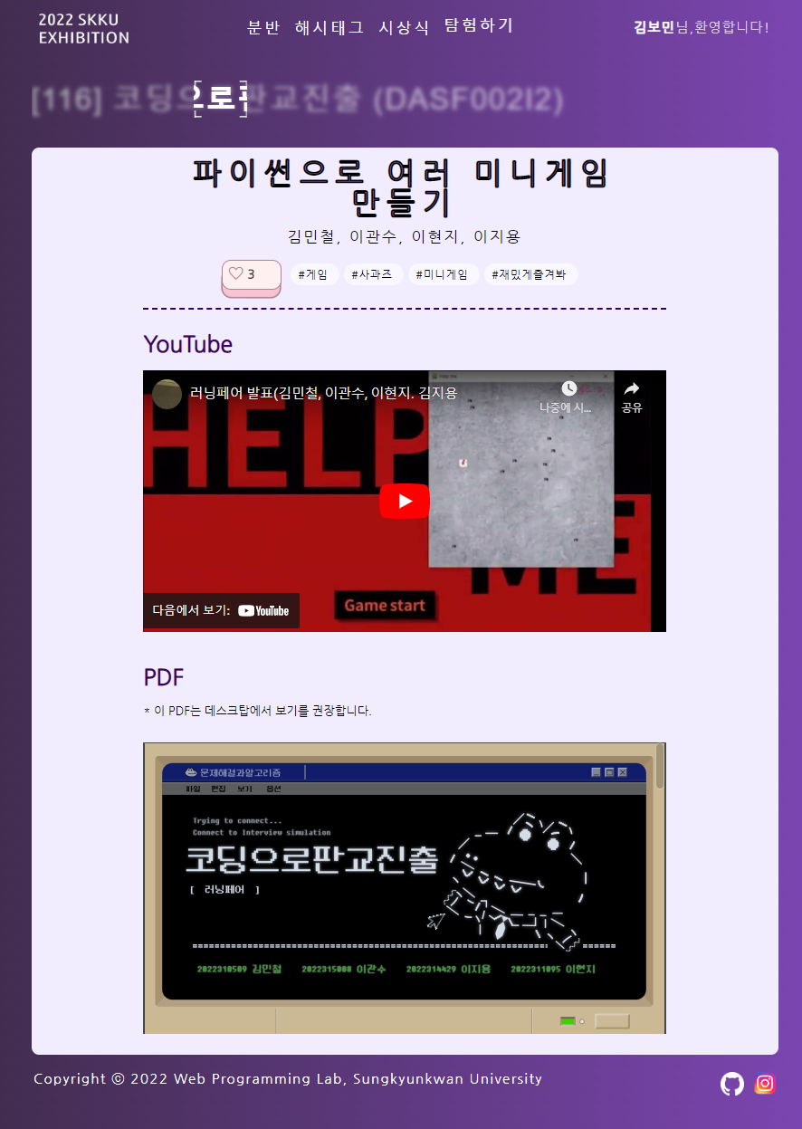

**Functions**

* Detailed page with full project information
* Class, and project number, project name, team name, team member information, hashtag, project description video and pdf, and number of likes can be checked
* If you press the "Like" button, the number of "Like" is +1, and if you press it again, it is -1.

**Css points**

* When 'Like' is pressed, the heart is filled with red, and if it is not pressed or canceled, it is changed to an empty heart

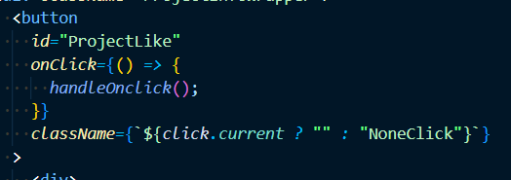

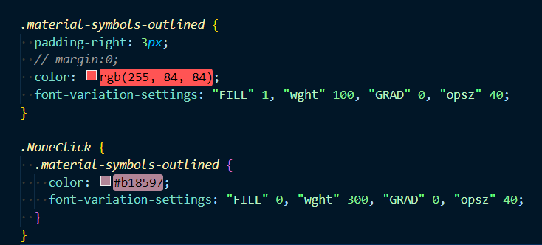

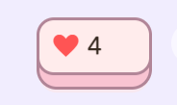 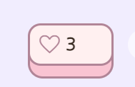

1. **Awards page**

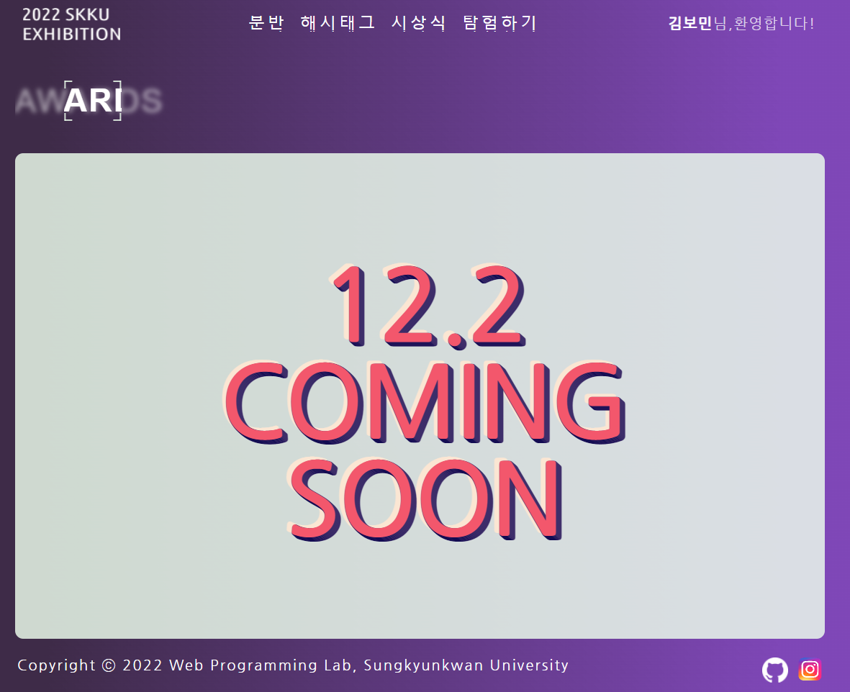

**Functions**

* Announcement of the planned awards ceremony schedule after the project exhibition

**Css points**

* a three-dimensional effect on words

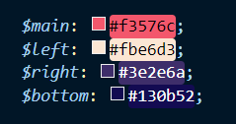

1. **Explore page**

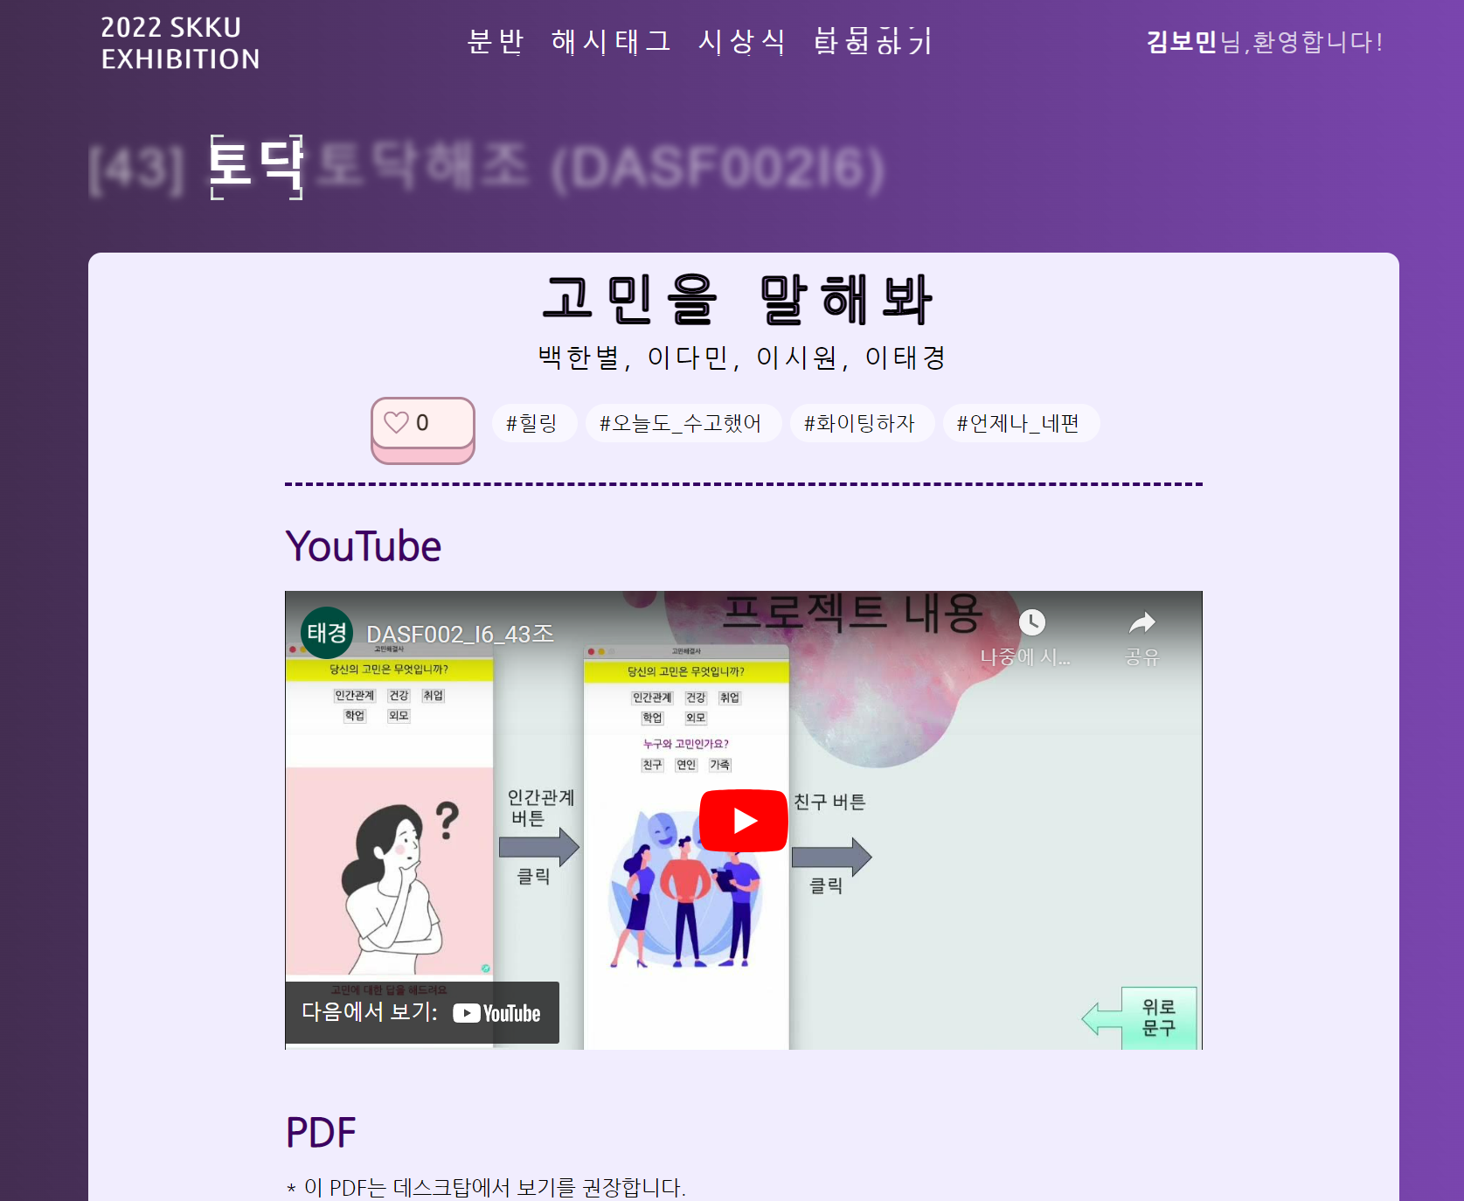

**Functions**

* Press the Explorer button to randomly post one of the displayed projects on the screen
* Explore page url and content composition are the same as project page.

